**Branching strategy**

Benefits having main and supporting branches:

* Feature development is isolated and doesn’t affect develop
* Parallel development is possible
* Develop branch will always be with completed features, ready for release if needed
* If feature is no longer needed or put on hold, no need to revert changes as they will be in separated feature branch
* Hotfix branches are very useful for critical bugs on production, no need to use the develop branch as the fix will be applied on master and the feature development will not be affected

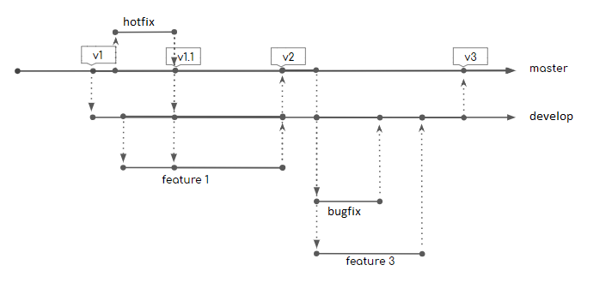

**Main branches**:

***master*** – infinite lifetime, reflects the current state of the last release, each release will come from the master branch and will be tagged with a named version.

***develop*** – infinite lifetime, reflects the current state of the next release.

**Supporting branches** (created with specific goal and destroyed when no longer needed):

***feature*** branch – created from develop, when the feature is ready to be released, the changes are merged into develop and the feature branch can be destroyed. After merging the branch can be destroyed. Prefixed with “feature/”

***bug fix*** branch - Prefixed with “bug/”, created from develop, when the fix is ready merged back to develop, similar to feature branch

***hotfix*** branch – used to fix critical problems on production, created from master, when the fix is ready merged back to master and develop, prefixed with “hotfix/”